Open Crochet Quick Start

**a mindfulness meditation practice**

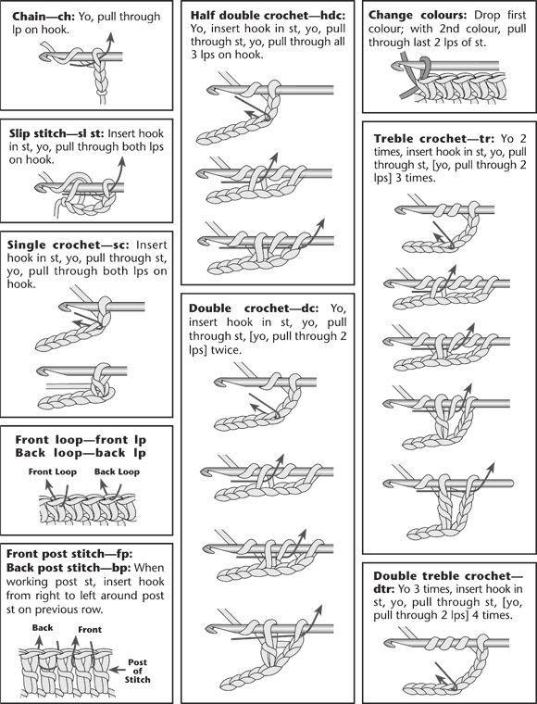

**Pattern:** Family Staircase  
**Stiches to know:** slip, chain, double  
**Why:**  learning a new skill and mindfulness are both great medicine for positivity and possibly more fun than traditional zen.  
**Contains:** 1 standard skein acrylic yarn & hook. Contact for more kits or other patterns:

The project has been started for you to focus on the basic pattern first.

# HOLDING THE YARN

Right hand: hold the hook like a pencil. Pinkie & ring finger probably behind project.

Left hand: hold project with all fingers but first. Point first finger. Yarn goes from ball up inside the palm, between 1st and 2nd finger, and over the top of the 1st finger to the hook. 1st finger maintains a comfortable tension.

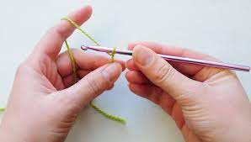

# BASIC PATTERN

1. slip stitch in the hole (under the first stitch on the next square in the staircase).

2. Chain 2 (counts as first double stitch)

3. Three more double crochet in the hole

Repeat

# EXPANDING/STARTING

At end of row (or at start of project) turn over and chain 5. Double crochet in the third stitch of the chain. Then the second and first stitch. Slip stitch in the next hole to continue the basic pattern…

# REDUCING

At the end of the row, slip stitch back in the last 3 stitches, chain 2 and 3 more double crochet to continue the basic pattern…

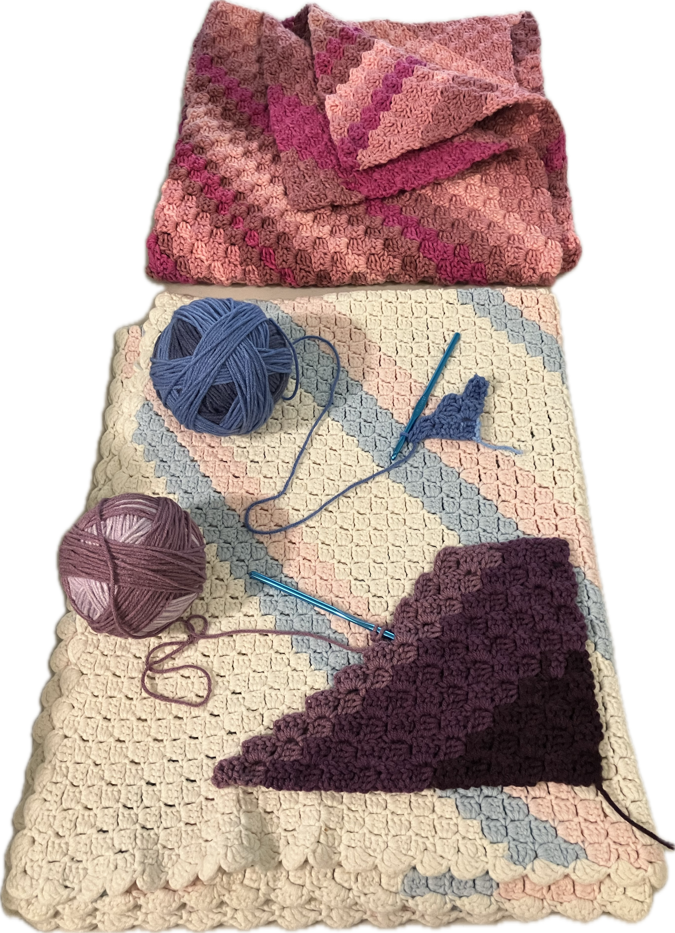

**Pattern: family staircase.** Use 4 or more skeins to make a baby blanket that’s great for tummy time. https://creativecommons.org/publicdomain/zero/1.0/